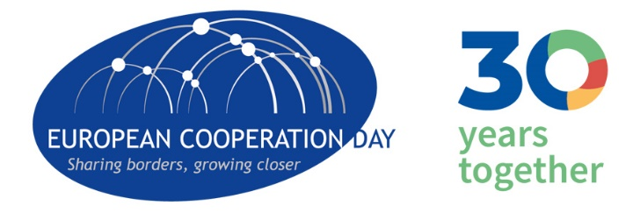
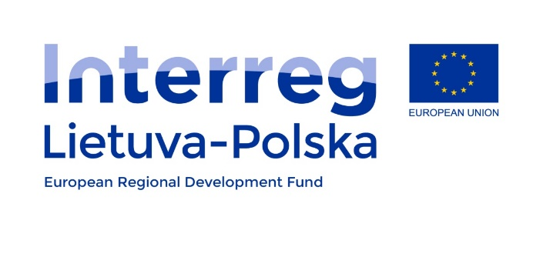

The Oak of European cooperation
29/09/2020

Oak – as a symbol of strength and longevity, it reflects the strong and long-lasting cooperation between Poland and Lithuania as well as steadfastness in obtaining European funds.
The oak of European cooperation planted in Puńsk – the capital of the Lithuanian national minority in Poland – is a symbol of Polish-Lithuanian cooperation over a dozen years. As part of the "INTERREG Lithuania-Poland" Program, the Puńsk commune, together with its partners from Lithuania, has implemented numerous projects which result in not only infrastructure facilities but also joint cultural, educational and training activities, as well as long-term partnership and trust. Thanks to jointly implemented projects, both partners from Poland and Lithuania gained new experience, and above all, established a thread of cooperation and friendship for many years.
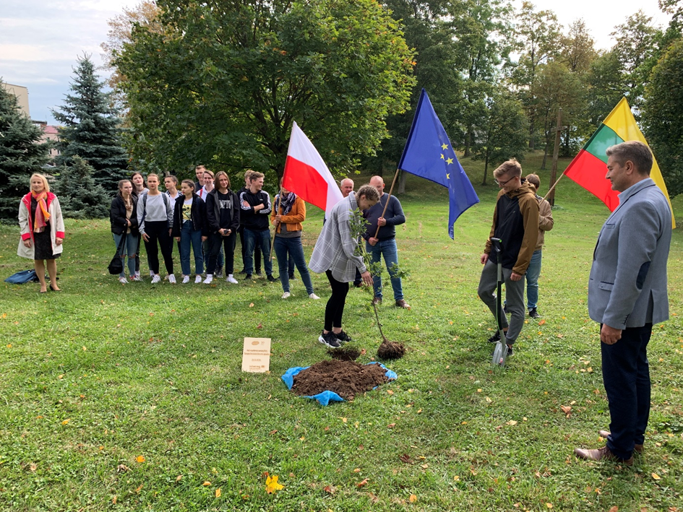

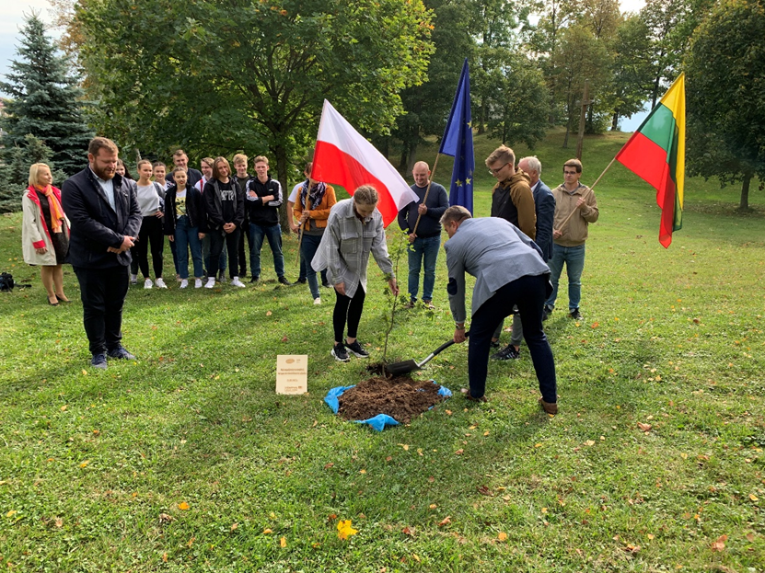
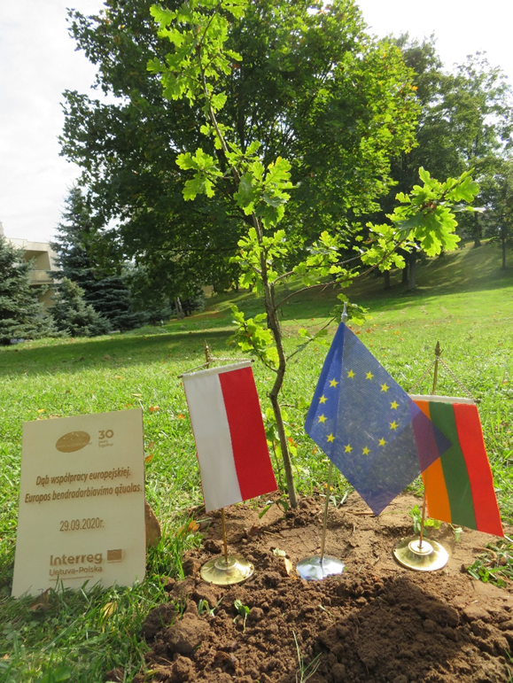

Here are some of the effects of the implementation of projects under the "INTERREG Lithuania-Poland" Program:
- Development of road infrastructure in the Polish-Lithuanian borderland
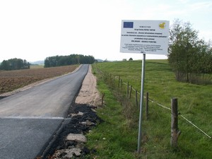

- Improvement of tourist contacts in the Polish-Lithuanian borderland by establishing tourist information centers and developing cooperation in the field of tourism on the border of Poland and Lithuania
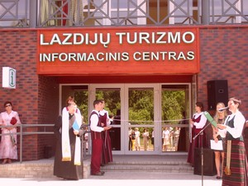

- Cultural cooperation between Poland and Lithuania
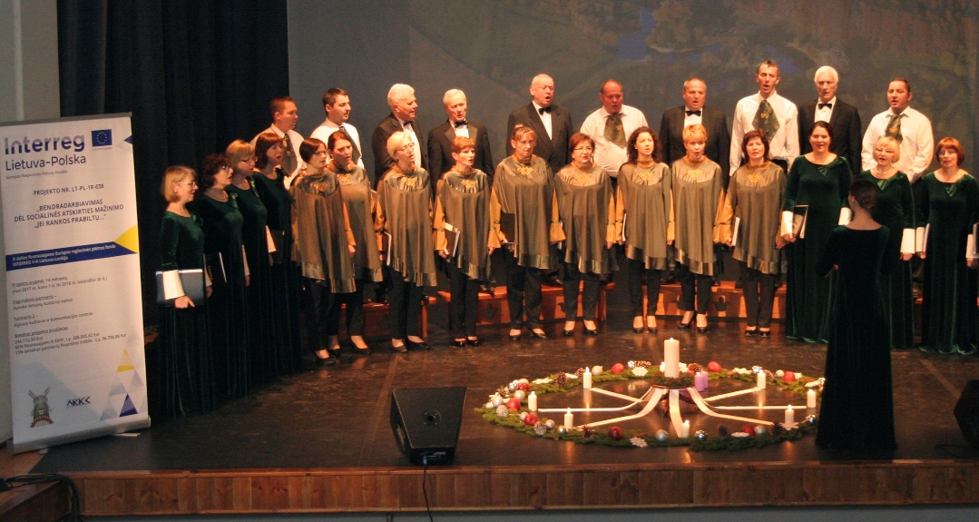
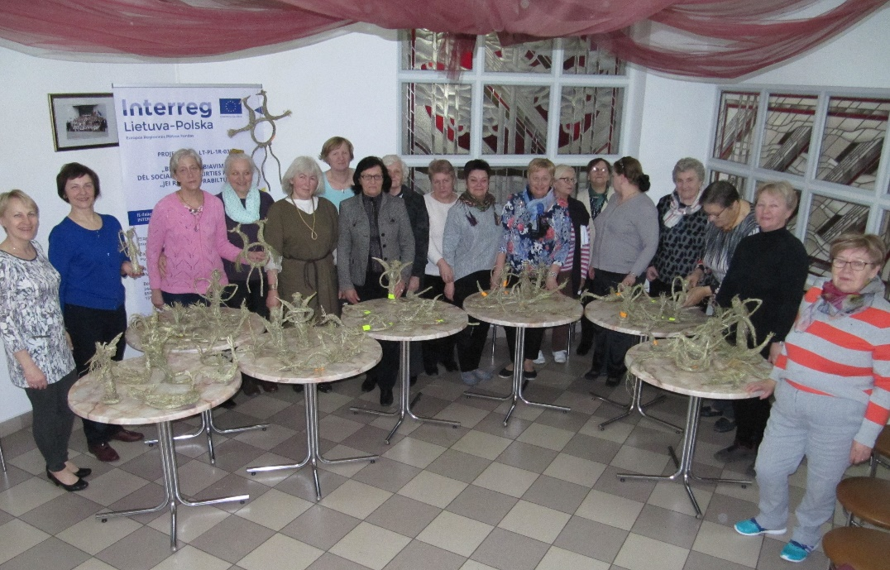
- Development of activities of joint rescue and fire protection services in the Polish-Lithuanian borderland and Cooperation of PL and LT in developing volunteering for the improvement of fire safety
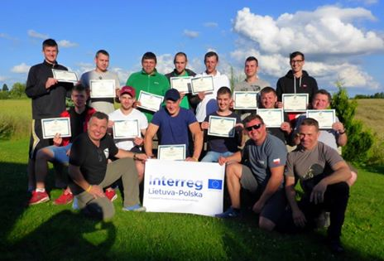
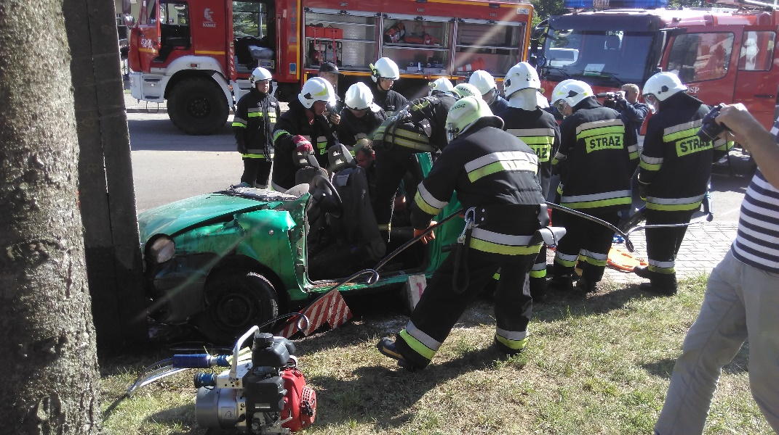
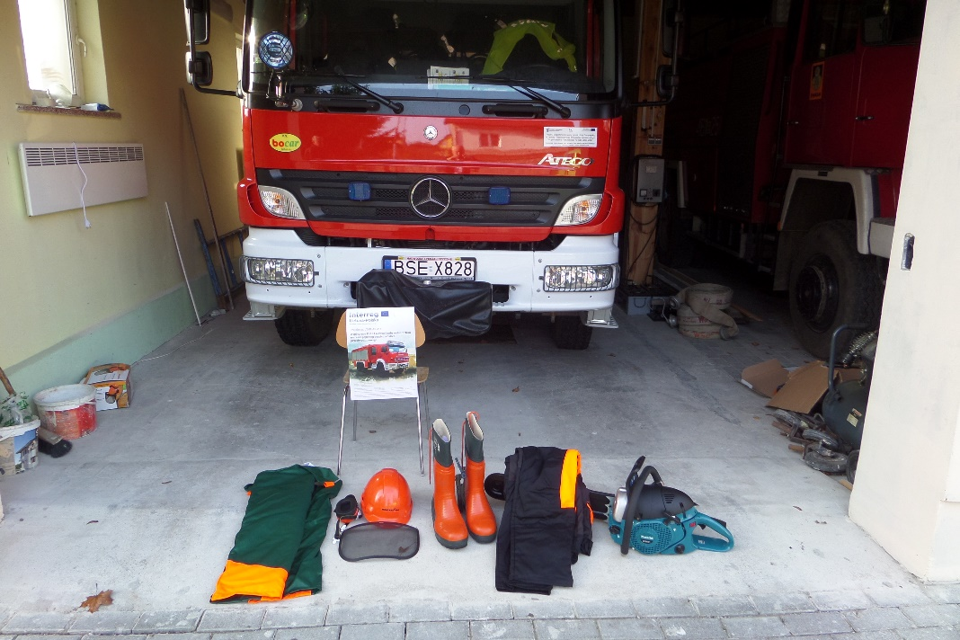

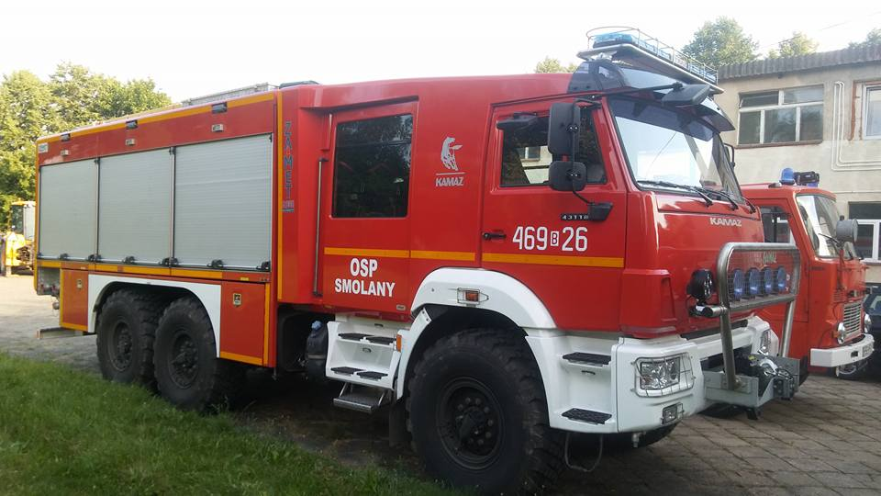

- Development of entrepreneurship in the Polish-Lithuanian borderland
- Cross-border cooperation for healthy old age and social well-being, incl. Renovation and modernization of the Independent Public Community Health Center in Puńsk
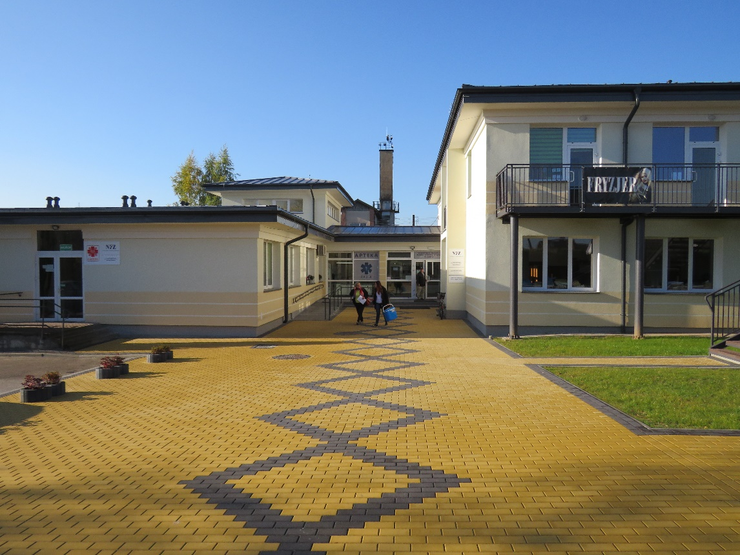
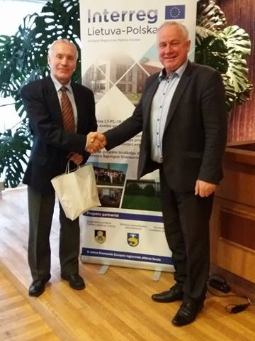
- Strengthening cooperation for the sustainable management of natural resources
- Increasing the attractiveness of libraries and cultural services in Pagėgiai and Puńsk
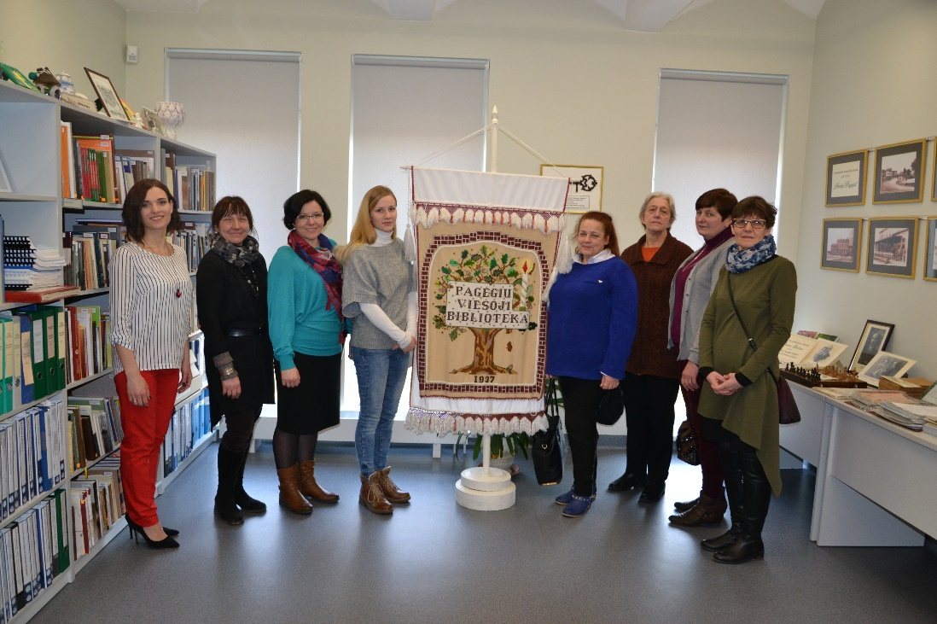
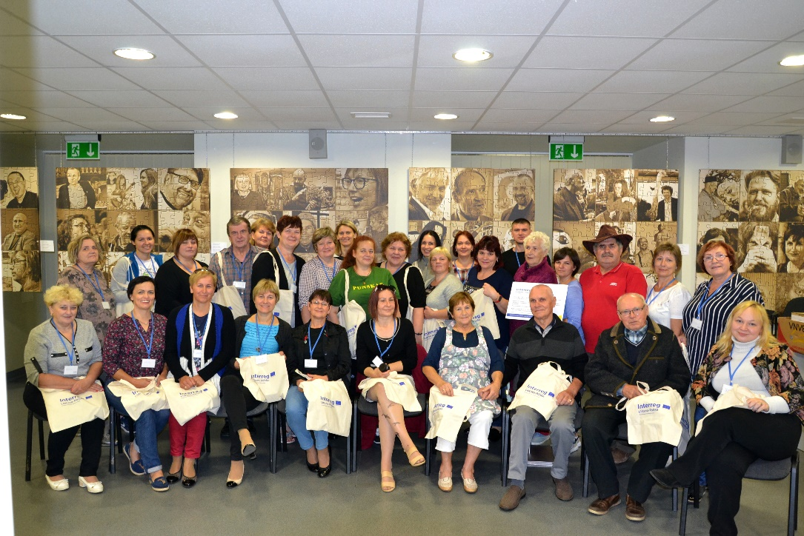

- Development of entrepreneurship in the Polish-Lithuanian borderland "Create entrepreneurship – reduce the difference"
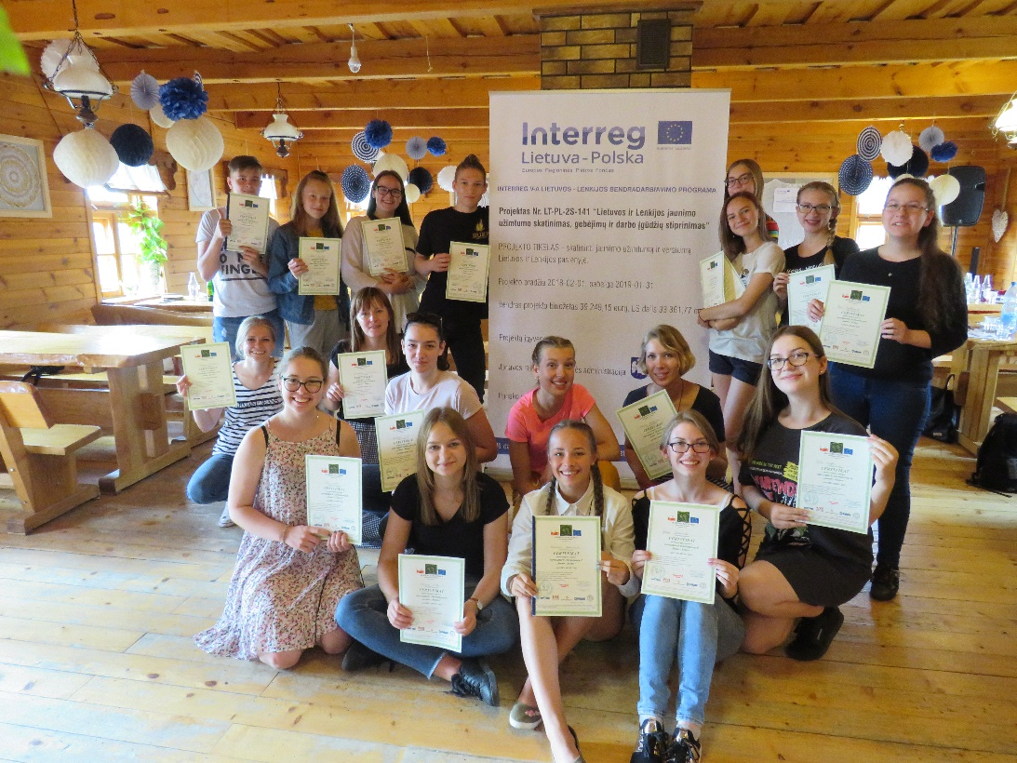
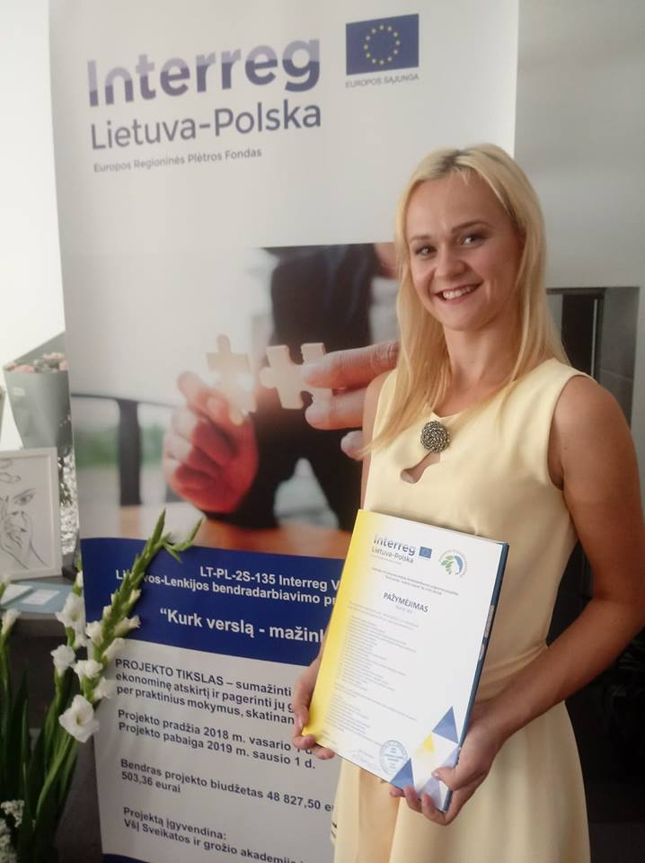

- Maintaining and promoting the heritage of the Baltic peoples on the Lithuanian-Polish border, including "Days of Yotvingian Crafts" and "International Day of Balts' Unity" in Puńsk
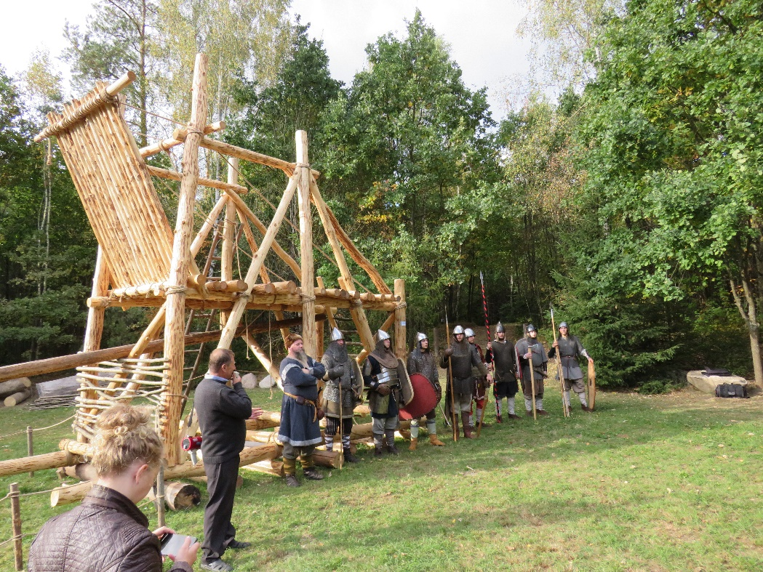
- Promoting employment and improving the professional qualifications of Lithuanian and Polish youth
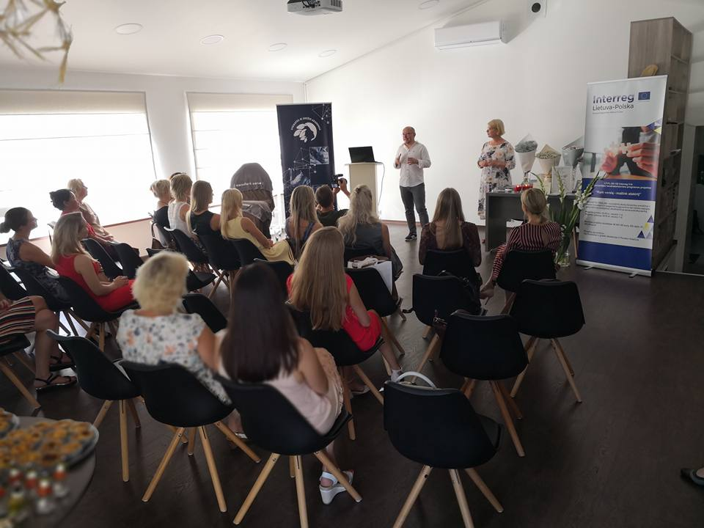

- "Lithuanian-Polish history from the perspective of three cities", incl. renovation of the old presbytery in Puńsk, plein air painting in Pagėgiai and handicraft workshops in Puńsk
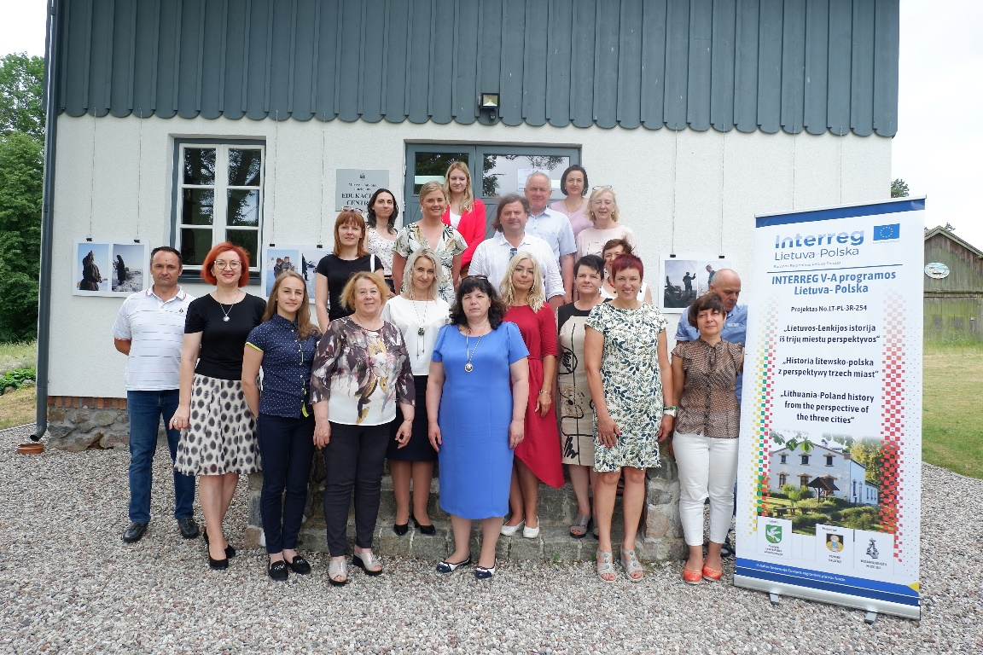

- "Strengthening cooperation in support of an aging society and social services"
